. MongoDB Console Screenshots:

o Provide screenshots of your MongoDB database showing collections.

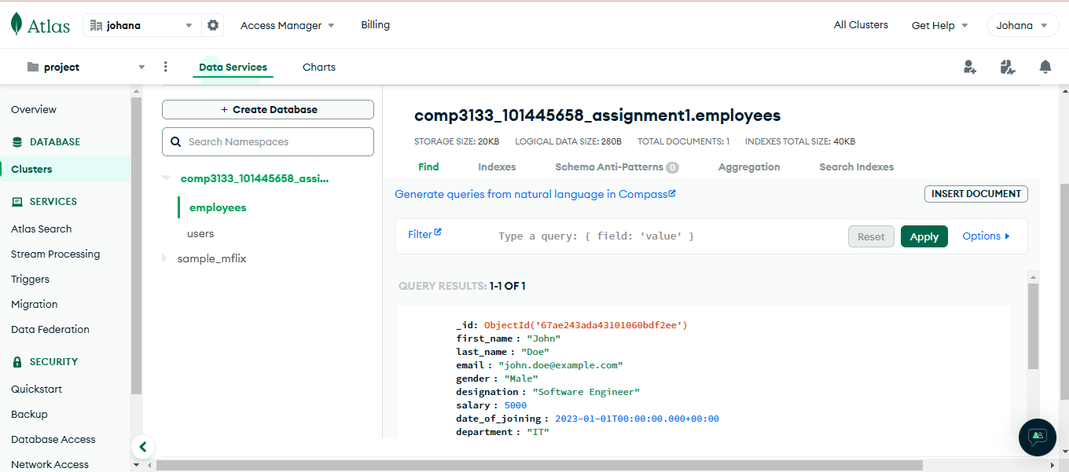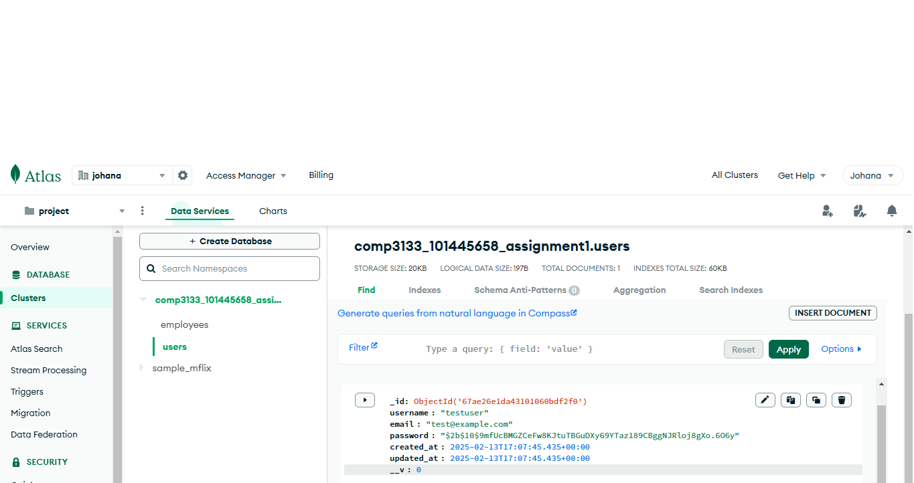

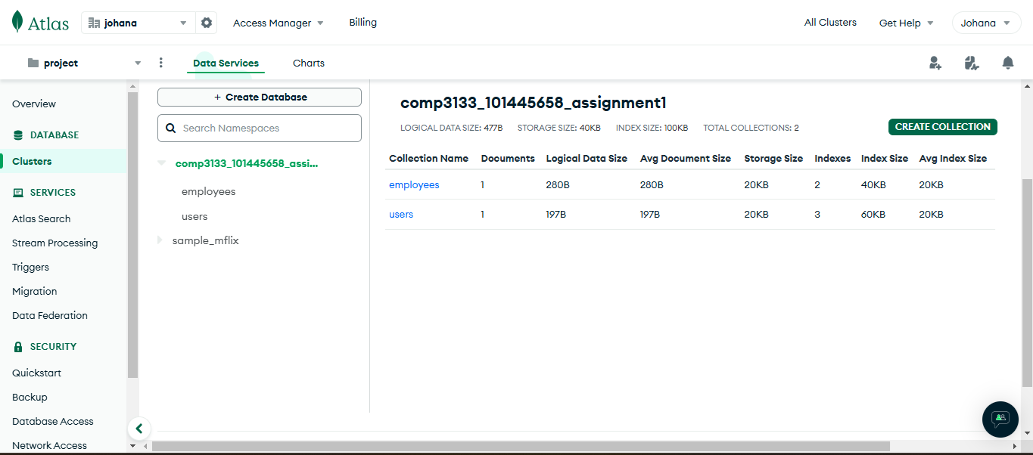

2. Postman API Collection:

o Export your Postman collection and include it in your submission.

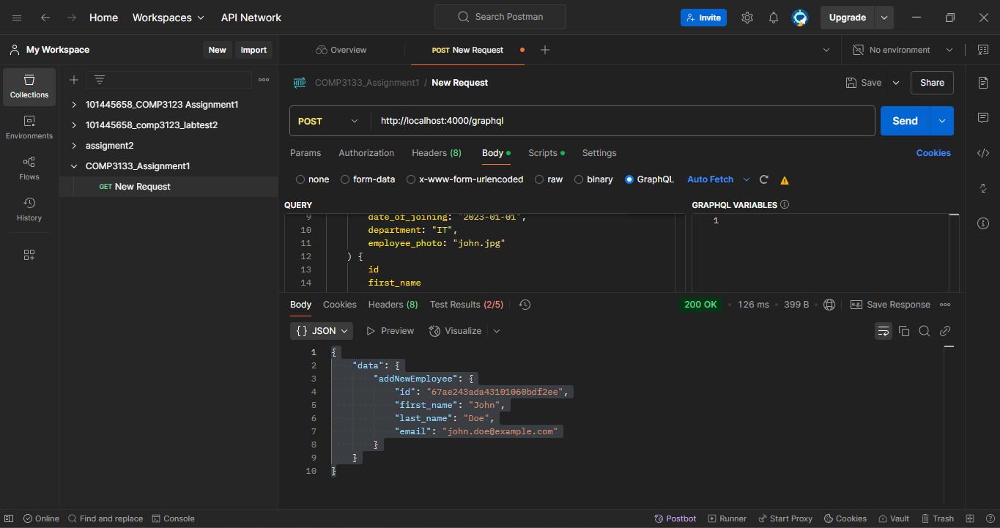

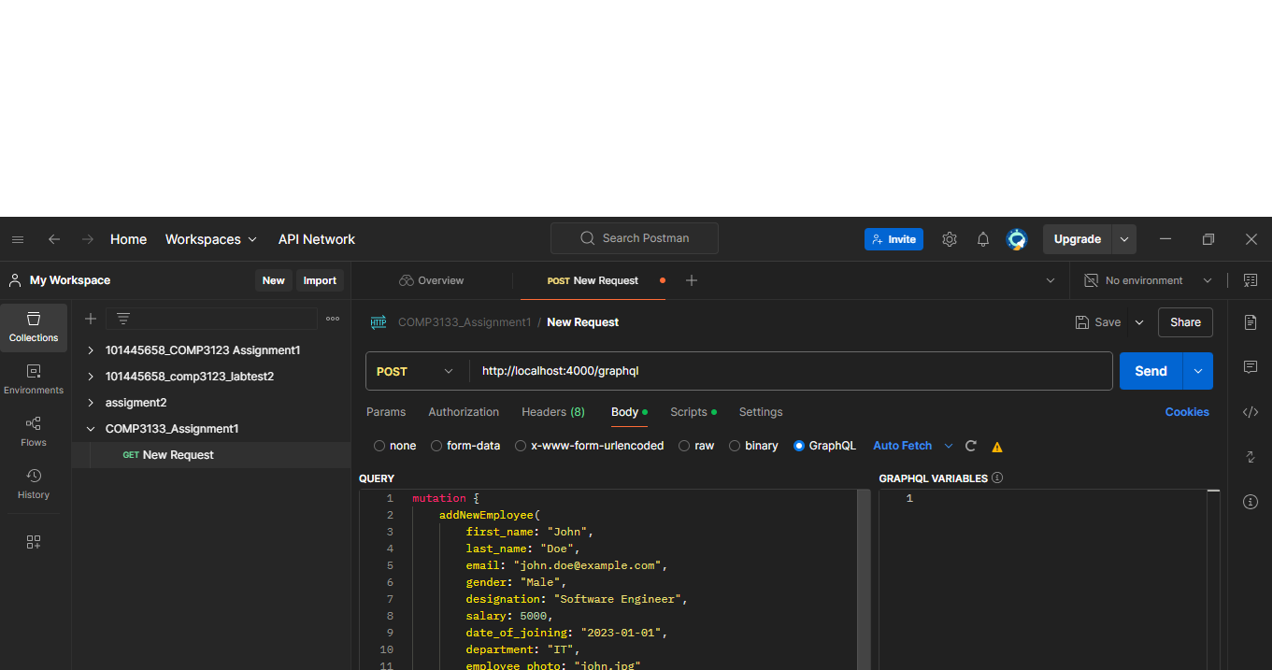

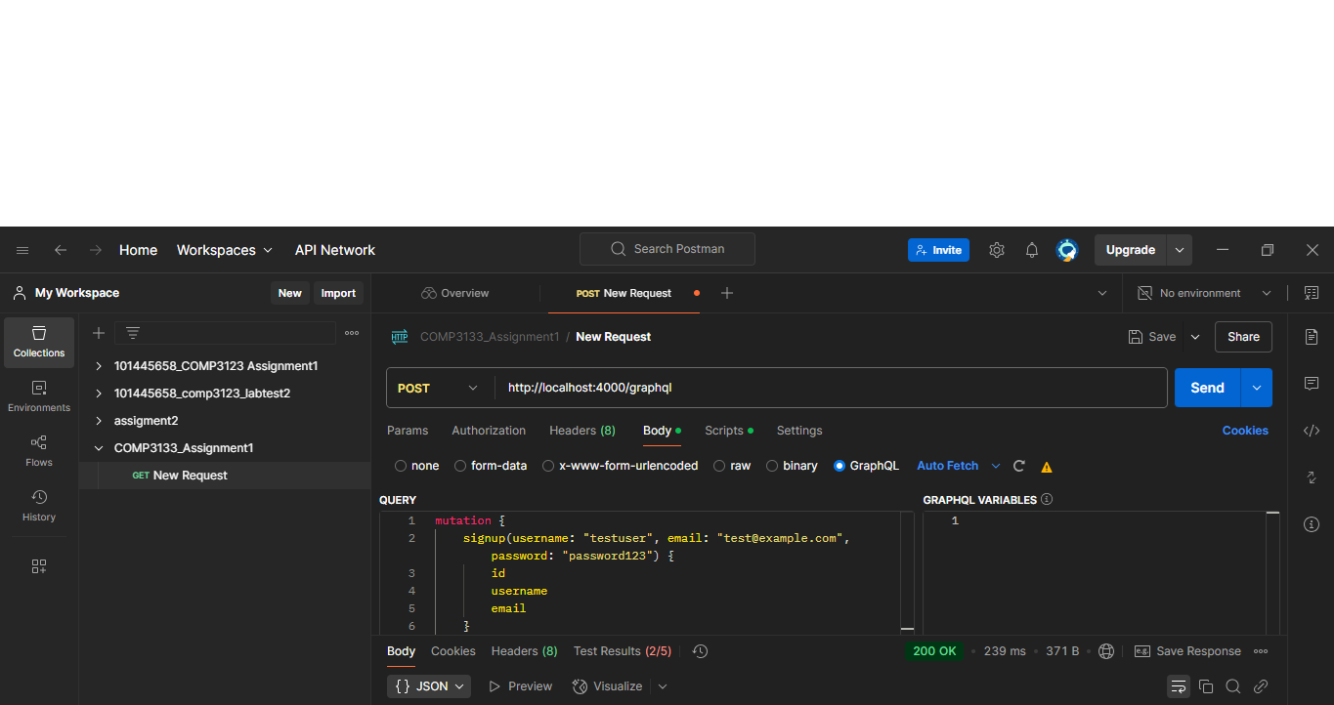

3. Screenshots:

o Include screenshots of each API being tested along with responses.

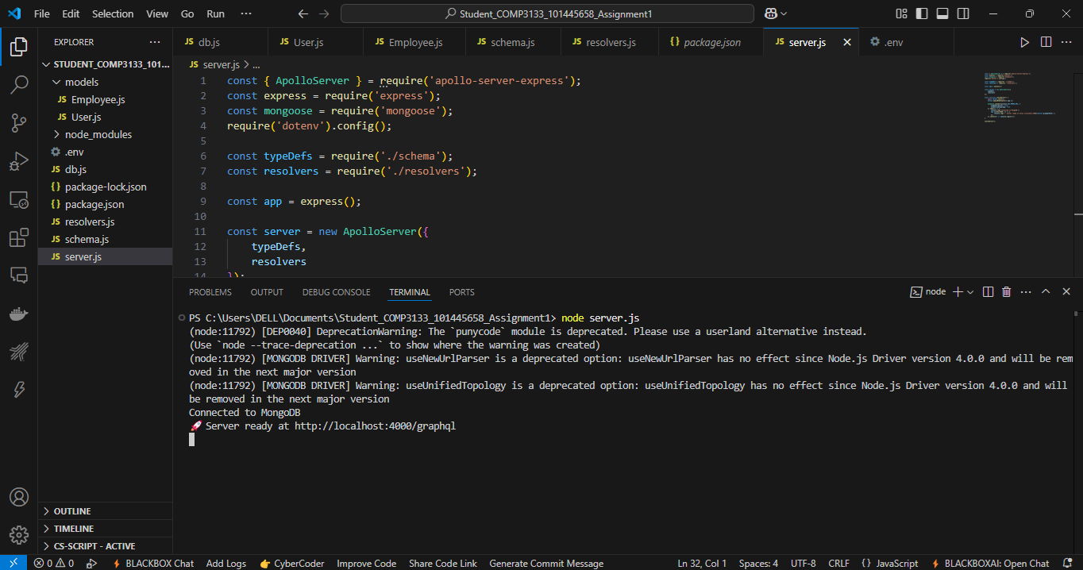

4. Project ZIP File:

o Remove the node_modules folder and create a ZIP file of your project.

5. GitHub Project Link:

o Provide the link to your GitHub repository.

6. Sample User Detail:

{

"name": "Leanne Graham",

"username": "Bret",

"email": "Sincere@april.biz",

"address": {

"street": "Kulas Light",

"suite": "Apt. 556",

"city": "Gwenborough",

"zipcode": "92998-3874",

"geo": {

"lat": "-37.3159",

"lng": "81.1496"

}

},

"phone": "1-770-736-8031",

"website": "http://hildegard.org",

"company": {

"name": "Romaguera-Crona",

"catchPhrase": "Multi-layered client-server neural-net",

"bs": "harness real-time e-markets"

}

}

7. Comments:

o Add any comments or notes that could be helpful.

8. Hosting:

o If hosted, provide the URL to your deployed application on platforms like

Vercel, Heroku, Render, etc